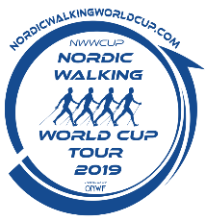
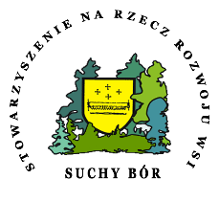
________________________________________________________________
CHAMPIONSHIP IN NORDIC WALKING WORLD CUP TOUR SUCHY BÓR 2019
REGULATIONS

- Organizers:
- Stowarzyszenie na Rzecz Rozwoju wsi Suchy Bór
- Pro Sport Wojciech Marcinkowski
- Honorary patronage:
- Marko Kantaneva (ONWF)
- Marshal of the Opolskie Voivodeship
- The event – purpose

- Promotion of healthy lifestyle and leisure activities
- Popularization of physical activity which is Nordic Walking
- Integration of people in all ages
- Popularization of correct Nordic Walking technique
- To determine the best athletes in different distance and age categories
- End of Nordic Walking World Cup Tour 2019 and determination of 2019 winners

- Date: 12th October 2019
- Place: Suchy Bór (Opolskie Region, commune Chrząstowice)
- Start/Finish: Grass Field WKS Suchy Bór,Szkolna 2 Street, 46-053 Suchy Bór, Poland

- Distance categories:
  - 5,27 km (1 lap) – electronic time measurement
  - 10,55 km (2 laps) – electronic time measurement
  - 21,09 km (4 laps) – electronic time measurement
- Limits of participants in different distance categories:
- distance 5,27 km – 160 people
- distance 10,55 km – 160 people
- distance 21,09 km – 80 people
Limits can be changed in accordance with the Organizers’ decision.
- Rules for participation:

- All participants must fill out electronic registration form on website https://timekeeper.pl/ and pay the registration fee on the Organizer’s account not later than 3 days before the competition.

- All participants must be verified at the competition office. Packets and start numbers will be given personally after showing Identification Documents with a date of birth and photo or after showing authorization which is available on the website https://timekeeper.pl/. The authorization should be printed, filled out and signed.

- All participants must show medical certificate which shows capacity for taking part in the competition or show signed document where will be written that he takes part in the competition on his own responsibility.

- All participants must agree on processing personal data by the Organizer of Championship in Nordic Walking on 12 th October 2019 and on other Organizer’s sporting events.

- In case of cancellation of registration, the fee will not be return to participant.

- Organizer is not providing with a VAT invoice.

- Participants at the age below 18 ( who on the day of the competition, 12th October 2019, do not reach the age of majority) are obliged to have a written permission with signature from their parents or legal guardians to participate in competition. The permission must have signature and PESEL number. Foreigners are required a passport number.

- Taking a start number means acceptation on the Championship regulations.

- Every participant is obliged to read the rules including the refereeing rules (Attachment No 1) and observe these rules.

- After registration and posting the registration fee, participant data (name, place of living, date of birth, name of club and sex) will be published on the list of participants on the website. Only the participants that are on the list and who have paid the registration fee, can take part in the competition.

- Start number will be given at the competition office after showing declaration of medical capacity. The announcement is available on the website https://timekeeper.pl/

- To be classified the participant must complete necessary formalities and finish the selected distance, by following the planned route.

- Participant can start in only one declared race.

- Participant at 10 km distance must be at least 14 years old, at 5 km distance younger participants are allowed.

- In the place of the competition stands a medical station. In case of injury, malaise or any harm, the participant is obliged to report these symptoms to the competition crew.

- Because of the security reasons, participants starts will follow in waves “. The participants will be set in age categories. Starts are in groups of 15-20 people.

- Participant that is not on the start line at determined in regulations time, will be disqualified. Please be punctual.

- Registration and registration fee:

- Registrations can be done only online at
- All participants must pay the registration fee.
- The registration fee is not refundable.
- World Cup Nordic Walking fee:
- up to 31th July 2019

-adults 25 euro (105 PLN)
-people from 14 years old to 18 years old 10 euro (42 PLN)

- from 1th August 2019 to 31th August 2019

- adults 35 euro (147 PLN)
- people from 14 years old to 18 years old 15 euro (63 PLN)

- from 1th September 2019 to 9th October 2019

- adults 45 euro (189 PLN)
- people from 14 years old to 18 years old 15 euro (63 PLN)

- The race of 5,27 km distance – participant needs to be at the age of 14 or older
- The race of 10,55 km distance – participant needs to be at the age of 14 or older
- The race of 21,09 km distance – participant needs to be at the age of 18 or older
- The registration is at https://timekeeper.pl/ from 1th July 2019 to 9th October 2019
- There will not be a possibility to register at the competition office.
- There is possibility of transfer fee on the other contestant up to September 30th. There is no possibility of changing race distance (transfer can be only made on the same race distance).
- Cancellation of registration and transfer a starter pack must be sent to nwwcup2019@nordicwalking.opole.pl.

- Route

- The route is set on forest tracks (about 2 km dirt road in the forest, near the start/finish place there is about 100 m of asphalt road and start and finish will take place on the grass field). The route is flat.

- Judges will be on the route to verify Nordic Walking techniques. (Please see the refereeing rules that are integral part of regulations- Attachment No 1)

- Refreshments points with water and food are set as shown on the map. In the area of the refreshment point (100 m) the Nordic Walking rules do not apply. Participants can take off gloves, but cannot run.

- The route will be set with markers and tape.

- The route map will be available on the website.

- On the route, there will be information tables with passing distance. It is only estimation and it can differ from the proper passing distance.

- In view of the date of the competition, mud and puddles can occur on the route.

- Minute program:

8.30 am Opening of competition office
10.00 am Official opening
10.30 am Women and men- 21,09 km distance
11.00 am Correct Nordic Walking technique shown by Marko Kantaneva
11.30 am Women and men- 10,55 km distance
12.30 pm Women and men- 5,27 km distance
1.00 pm Non-competitive walk - 5,27 km (mass start) without time measurement. (Details in Regulations of Non-Competitive Walk Nordic Walking unites the Europe on 5km distance on the website www.nordicwalking.opole.pl).
Around 3.30-4 pm official results announcement and participants decoration.
4.15 pm Prize game
Minute program can be changed. The particular information will be at www.nordicwalking.opole.plon the day of the competition.
The competition office will be marked and opened from 8.30 to 11 am. After closing of the office, there will be no possibility of registration and receiving the start packet.
- Time measurement and start number:

- Time of contestants is taken by electronic chips.

- Start number contains of two identical parts. One should be placed in the front and in the way that referees can see it (chest, belly), the other part should be placed in the same way on the back.

- Competitors are obey to place the start numbers on outer layer of clothing, they cannot be covered. In that case, the referee can stop the contestant to place correctly the start number.

- The start number worn by the competitor must be correspondent to the number on the start list.

- The start number is provided at the registration. The contestant that will start with another number then provided, will be disqualified.

- Start packet:

Every participant will be provided with:

- start number,
- electronic chip, that will measure time and should be attached to the shoe,
- drink,
- nutrition bar,
- accident insurance,
- coupon for a meal.

- Referees

- On the route there will be referees, who will be responsible for Nordic Walking techniques assessment. They will be responsible also for penalising the breaches of event’s and Nordic Walking’s rules.
- The incorrect technique will be penalised in accordance with the refereeing rules that are integral part of regulations- Attachment No 1”.
- The route will be recorded by cams and drones. The records might provide an argument in case of ambiguities.
- The tapes will be an object of analysis for referees. After the breakdown of the records, referees are allowed to disqualify a contestant and deprive him of a title in case of significant breach of the fair play rule (inappropriate behaviour of the contestant on the length where the referees have been absent)
- The final results of the Championship will be published as soon as they get approved by the general referee.
- In case of disqualification the contestant is neither allowed to claim the registration fee nor to take part in the prize game.

- Final qualifications
- Age categories:
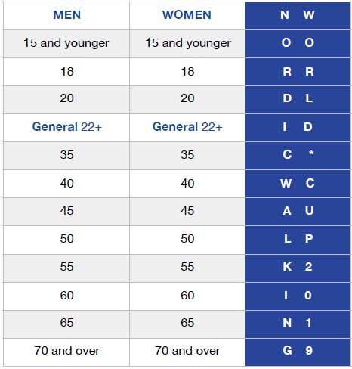
World Cap Tour 2019 Scoring: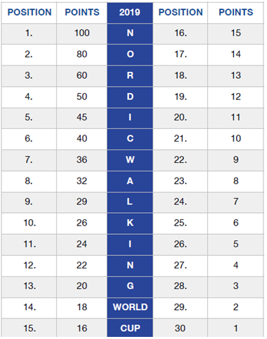
- Final Provisions:

- Competition will take place no matter of the weather conditions.

- The refereeing rules are integral part of the regulations, please see attachment No 1 available on website http://nordicwalking.opole.pl/nordic-walking-world-cup-tour-2019

- Any ambiguities are determined by the general referee. There is no possibility to revoke or change this decision.

- All participants should respect fire safety rules, as well as nature conservation (please do not leave garbage, cups, wipes etc. in the forest- with the exception off refreshment point’s area, please follow the marked route, respecting the nature). Please also keep your surroundings tidy at the event’s place.

- The Organizer does not take responsibility of lost staff and damages caused by other participants.

- Deposit is returned only after presenting start number. In case of losing this number, the Organizer does not have to return the deposit to the other person. Valuable staff cannot be place in the deposit.

- The Organizer has got liability insurance, which is based on general insurance conditions.

- The participant, who took the start number declares, that he has read and accepted these regulations.

- The complaint concerning results can be reported no later than 30 min from the results official publication. In order to lodge the complaint, 100 PLN fee is required which is returned when the complaint had been accepted.

- During the event, there is prohibition of using alcohol, drugs, performance-enhancing drugs and smoking (including e-cigarette).

- Final interpretation of the regulations belongs to the Organizer.

- Personal Data Processing in accordance to General Data Protection Regulation:
Pursuant to Article 13 of the Regulation (EU) of the European Parliament and of the Council of 27 April 2016 on the protection of natural persons with regard to the processing of their personal data (Official Journal of the European Union L 119 of 4 May 2016), by sending correctly filled out and signed registration form participant declares that he agrees on processing personal data by the Organizer for sending information about future events, commercial products, as well as for administration and analysis. The participant can withdraw such agreement at any time by sending the correspondence to the Organizer.

- Information on personal portrayal publishing
The participant agrees on filming and photographing himself and using the footage and his personal portrayal now and in the future to verify, classify and promote, as well as for marketing operations and reporting of the competition for other entities, including sponsors, radio station, television and event’s patrons.
Suchy Bór, June 27th 2019.

